AI-102 Day 6 all screenshots

AI102-Day06-06-RG-Deletion in progress.png

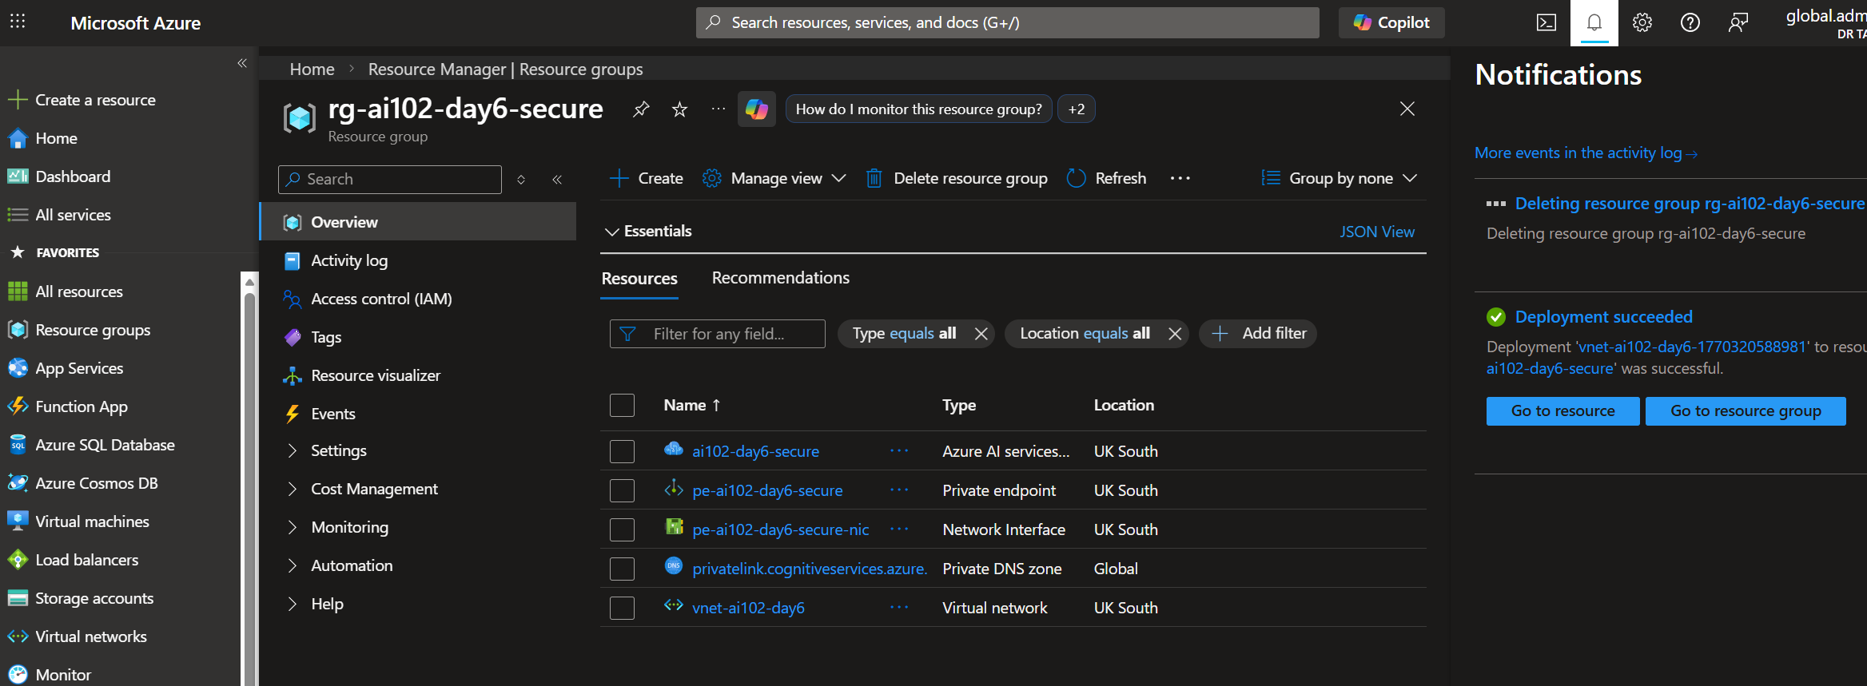

AI102-Day06-06-RG-Deletion.png

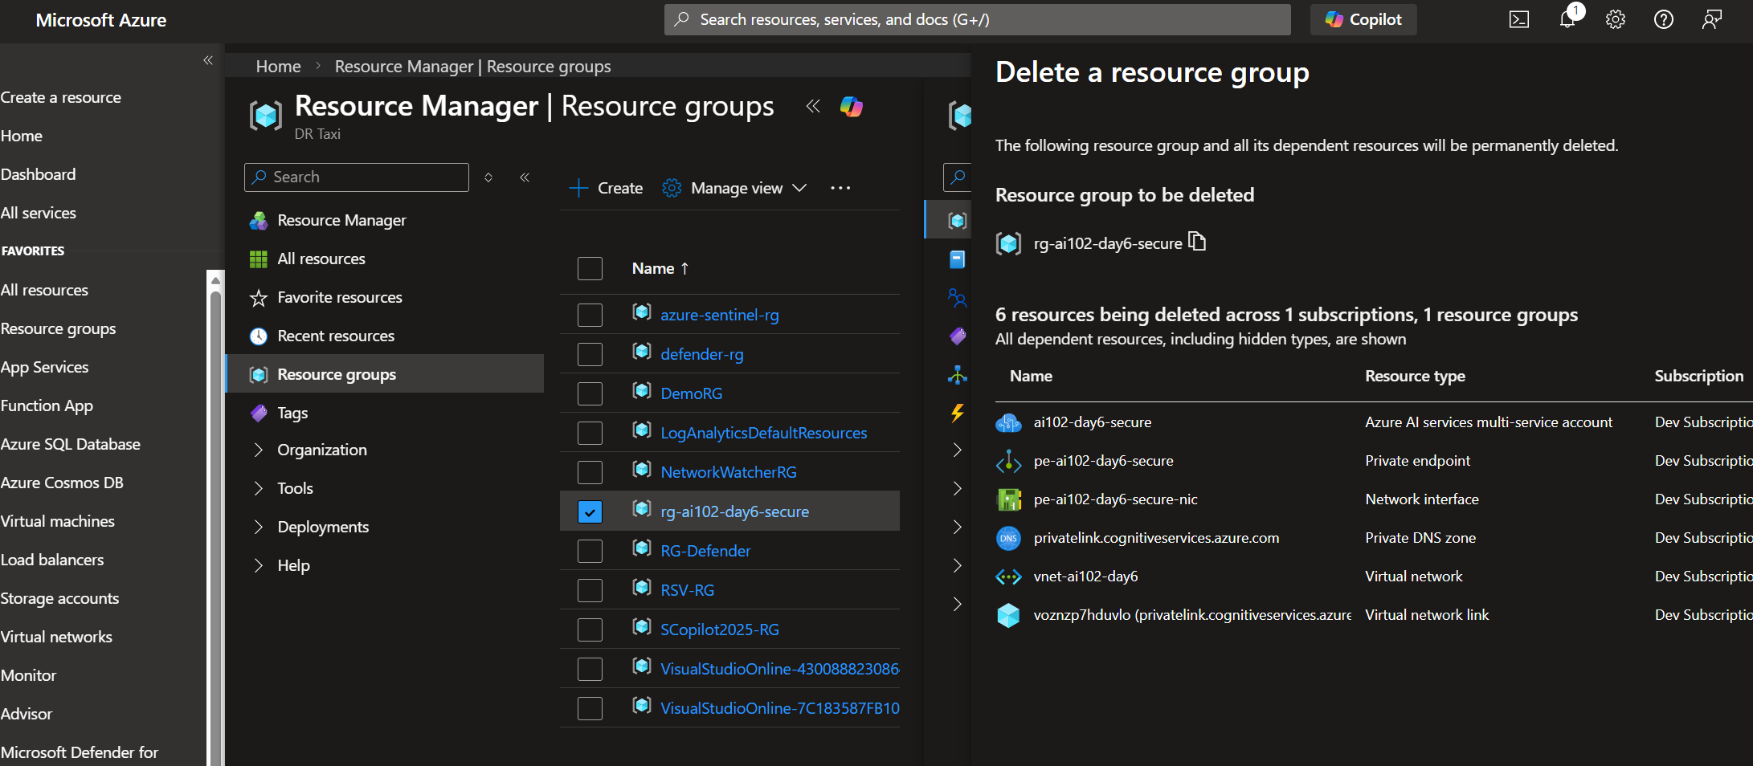

AI102-Day06-07-DNS-Configured.png
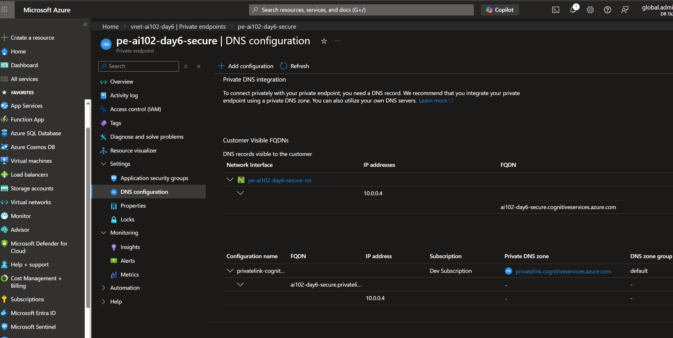

AI102-Day06-06-PE-Approved.png
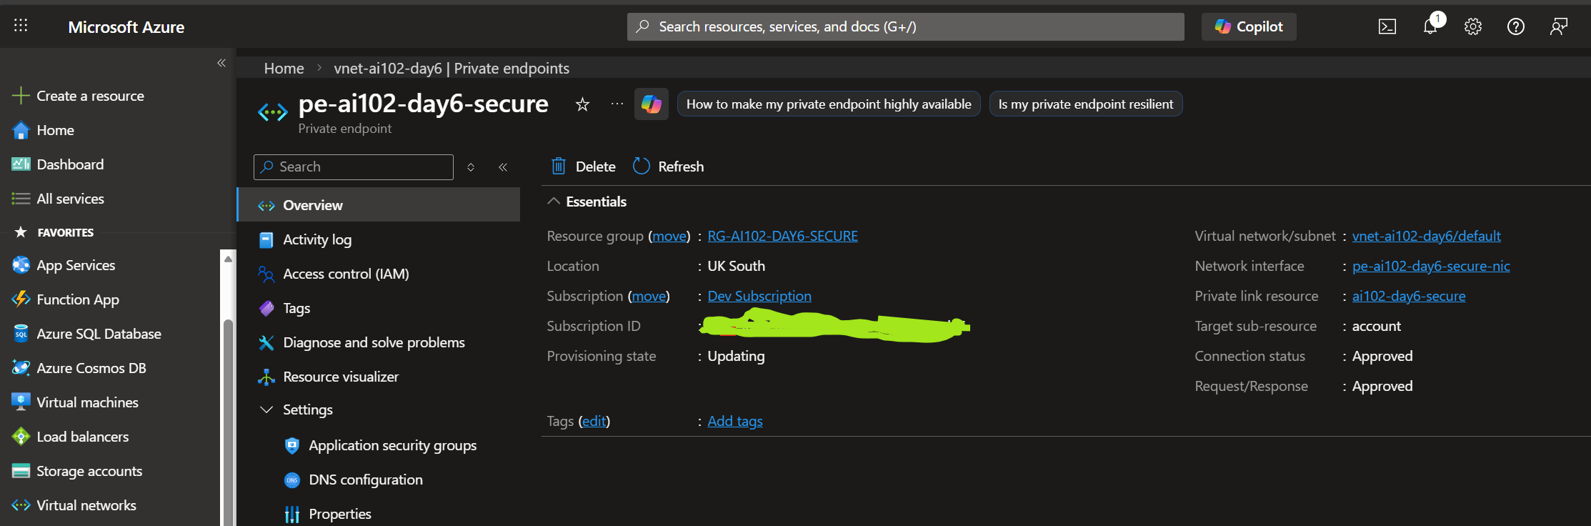

AI102-Day06-03-Public-Network-Disabled.png
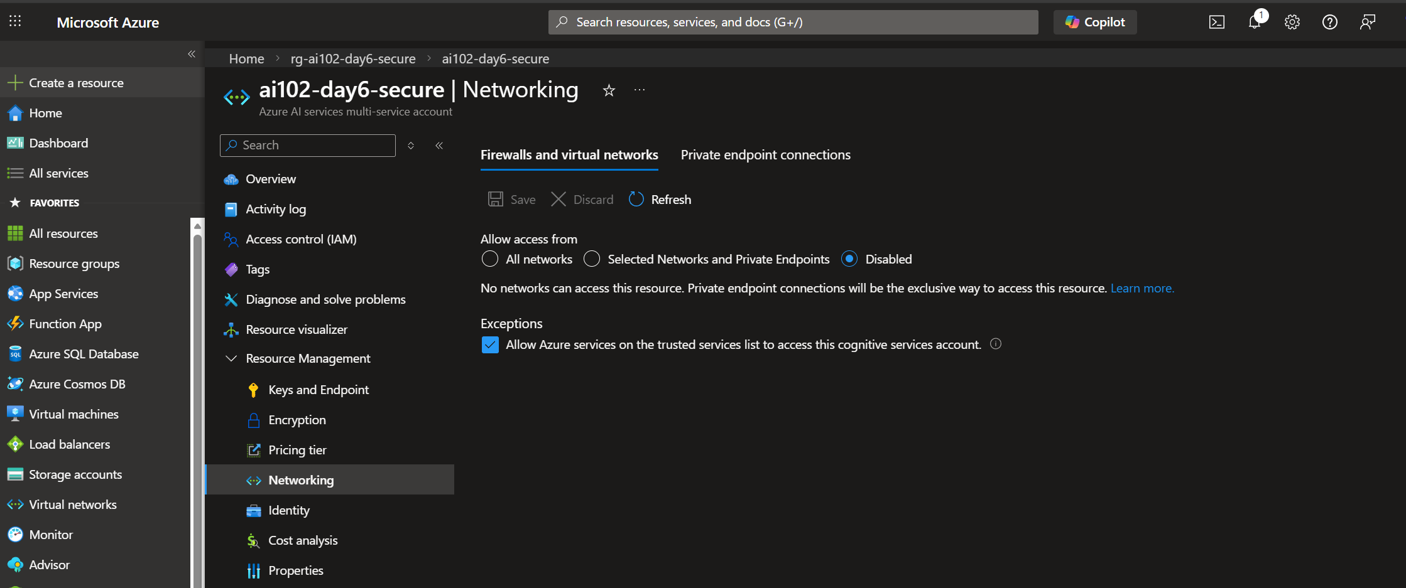

AI102-Day06-02-AI-Service-Created.png
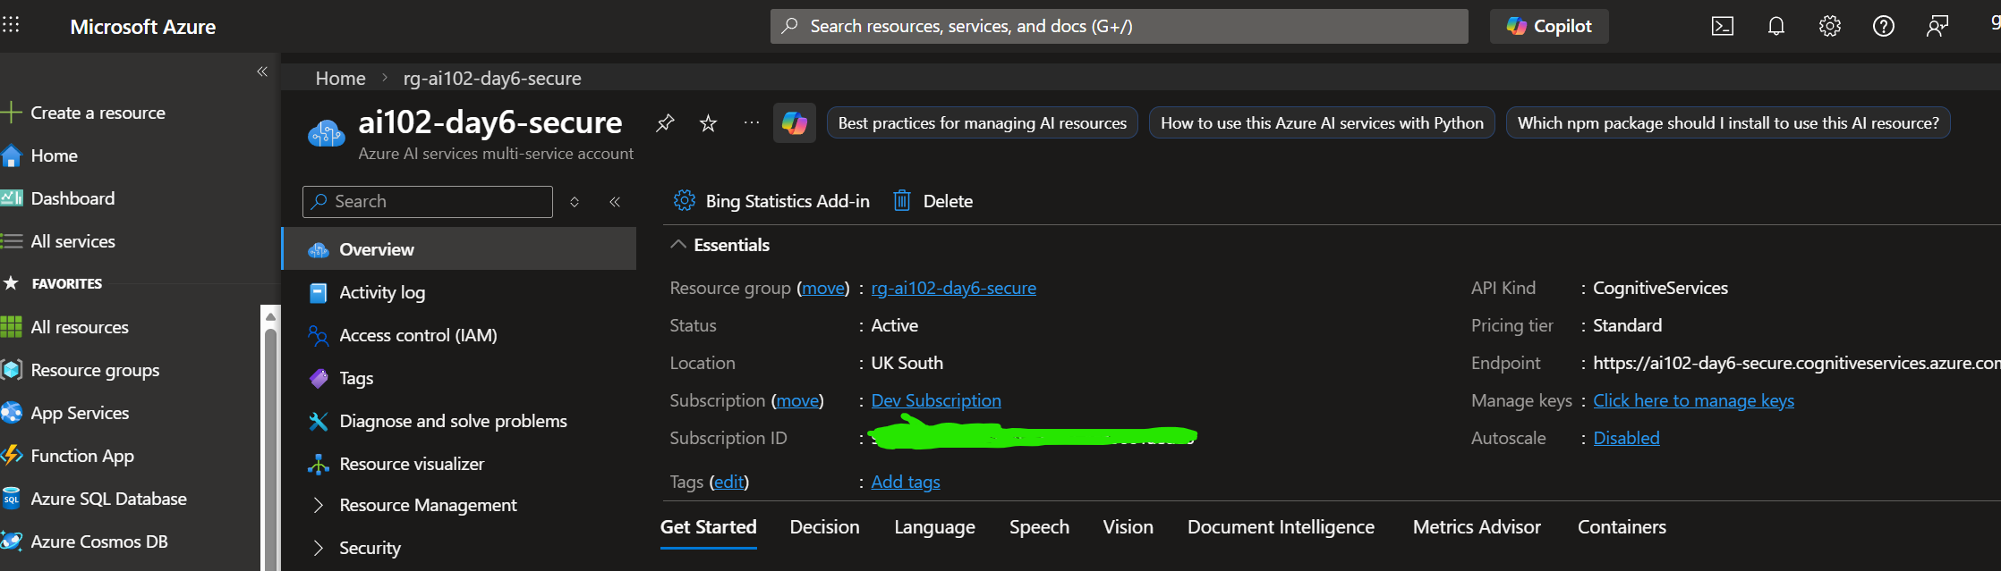

AI102-Day06-01-RG-Created.png
